**INSTITUTE OF AERONAUTICAL ENGINEERING**

**DUNDIGAL, HYDERABAD.**



**GSM BASED FIRE DETECTION AND FIRE CONTROLLING**

**SYSTEM**

**BY**

**C.PRALAVI**

**21955A0415**

**ELECTRONICS AND COMMUNICATION ENGINEERING**

**UNDER THE GUIDENCES**

**OF**

**DR. D. SRIKAR SIR**

# **CERTIFICATE**

This is to certify that this project report is the bonafide work of **CHILUKURI PRALAVI** of roll no **21955A0415** who carried the project entitled “**GSM BASED FIRE DETECTION AND FIRE CONTROLLING SYSTEM**” under our supervision.

Submitted for Viva voice Examination held on____________________________

Internal Examiner External Examiner

# **DECLARATION**

I, CHILUKURI. PRALAVI (21955A0415), hereby declare that the Project Report entitled “GSM BASED FIRE DETECTION AND FIRE CONTROLLING SYSTEM” done by me under the guidance of SRIKAR SIR, is submitted in Problem based learning.

DATE:

PLACE:

SIGNATURE OF THECANDIDATE:

# **ACKNOWLEDGEMENT**

We are pleased to acknowledge our sincere thanks to Board of management of IARE for their kind encouragement in doing this project and for completing it successfully. I am grateful to them.

We would like to express our sincere and deep sense of gratitude to our Project Guide SRIKAR SIR for her valuable guidance, suggestions and constant encouragement paved way

**ABSTRACT**

Now a days, every system is automated in order to face new Challenges in the present situation. Automated systems have less Manual operations, so that the flexibility, reliabilities are high and Accurate. Hence, each and every field prefers automated control system. Especially in the field of electronics automated systems are doing better Performance increasingly. The project itself indicates that the system checks the fire in the industry, based on that we get a message alert and a call alert to the Registered mobile number and automatically motor star pumping water to stop the fire. Here we use one fire sensor. When fire is detected by the flame sensor then it gives high signal To Arduino input. Arduino is programmed in such a way that it gives the message and call alert to the user/owner through the GSM 900A.

**CHAPTER 1: INTRODUCTION**

**1.1 INTRODUCTION TO EMBEDDED**

**1.11** INTRODUCTION

An Embedded System is a combination of computer hardware and software, and perhaps additional mechanical or other parts, designed to perform a specific function. A good example is the microwave oven. Almost every household has one, and tens of millions of them are used every day, but very few people realize that a processor and software are involved in the preparation of their lunch or dinner.

This is in direct contrast to the personal computer in the family room. It too is comprised of computer hardware and software and mechanical components (disk drives, for example). However, a personal computer is not designed to perform a specific function rather; it is able to do many different things. Many people use the term general-purpose computer to make this distinction clear. As shipped, a general-purpose computer is a blank slate; the manufacturer does not know what the customer will do wish it. One customer may use it for a network file server another may use it exclusively for playing games, and a third may use it to write the next great American novel.

Frequently, an embedded system is a component within some larger system. For example, modern cars and trucks contain many embedded systems. One embedded system controls the anti-lock brakes, other monitors and controls the vehicle’s emissions, and a third displays information on the dashboard. In some cases, these embedded systems are connected by some sort of a communication network, but that is certainly not a requirement.

At the possible risk of confusing you, it is important to point out that a general-purpose computer is itself made up of numerous embedded systems. For example, my computer consists of a keyboard, mouse, video card, modem, hard drive, floppy drive, and sound card each of which is an embedded system. Each of these devices contains a processor and software and is designed to perform a specific function. For example, the modem is designed to send and receive digital data over analog telephone line. That’s it and all of the other devices can be summarized in a single sentence as well.

If an embedded system is designed well, the existence of the processor and software could be completely unnoticed by the user of the device. Such is the case for a microwave oven, VCR, or alarm clock. In some cases, it would even be possible to build an equivalent device that does not contain the processor and software. This could be done by replacing the combination with a custom integrated circuit that performs the same functions in hardware. However, a lot of flexibility is lost when a design is hard-cooled in this way. It is much easier, and cheaper, to change a few lines of software than to redesign a piece of custom hardware.

**1.12 CHARACTERISTICS OF EMEBEDDED SYSTEM**

• Requires continuous execution.

• It ought to have high accessibility and dependability.

• Created around an on-going working framework.

• For the most part, have simple and a diskless activity, ROM boot.

• Intended for one explicit assignment.

• It should be associated with peripherals to interface info and yield gadgets.

• Offers high unwavering quality and strength.

• Required negligible UI

• Restricted memory, ease, less force utilization.

• It needn’t bother with any optional memory in PC.

**1.13 Real Time Systems**

One subclass of embedded is worthy of an introduction at this point. As commonly defined, a real-time system is a computer system that has timing constraints. In other words, a real-time system is partly specified in terms of its ability to make certain calculations or decisions in a timely manner. These important calculations are said to have deadlines for completion. And, for all practical purposes, a missed deadline is just as bad as a wrong answer. The issue of what if a deadline is missed is a crucial one. For example, if the real-time system is part of an airplane’s flight control system, it is possible for the lives of the passengers and crew to be endangered by a single missed deadline. However, if instead the system is involved in satellite communication, the damage could be limited to a single corrupt data packet. The more severe the consequences, the more likely it will be said that the deadline is “hard” and thus, the system is a hard real-time system. Real-time systems at the other end of this discussion are said to have “soft” deadlines.

**CHAPTER 2: LITERATURE SURVEY**

**2.1 GSM based fire alarm System**

Authors: Dheeraj Munagala, Syed Maseeh Uddin and Prathik Reddy

In this project, we are going to describe the usage and numerous advantages of a Fire alarm system in daily life. It has a great scope in daily life as it can be used in various fields and the best part about it is we will receive a text message if the fire is detected. This project can be implemented in industries, mines, colleges, etc. Security and automation are prime worries in our everyday life. The way to deal with home and industrial automation and security framework design is nearly institutionalized these days. Everybody wants to be secure. So, every user can use this fire sensor, temperature sensor, gas sensor, the smoke sensor at home and enterprises. The objectives of this fire detector using Arduino are to sense the surroundings for the occurrence of fire with help of temperature sensor and send 3 SMS alerts to two mobile numbers stored inside the Arduino program if the fire is detected.

**2.2 A review on GSM Based fire alarm system module**

Author: Md Turab Hoosain

A Microcontroller based house fire alarm system using a GSM Module is described in this paper. The project's primary goal is to keep residents and their belongings safe from fires, which are a common hazard in residential areas. It uses an Arduino Uno board and an ATmega328 microcontroller. The ATmega328 is the primary controller for the temperature-triggered fire alarm in the average home. The fire's heat is detected by an LM35 temperature sensor. The GSM module will use SMS to send an alarm to the user's mobile phone. A warning message will appear on the LCD display and an SMS alert will be sent to the user's phone when the temperature rises above 400C. Documentation and discussion of the test's outcomes are required. This device can assist users enhance their safety standards by providing an early response in the event of a potential accident. Finally, users will be able to protect themselves, as well as those they care about, from disaster.

**2.3 GSM based Fire Alarm System using Arduino**

Authors: Sheilame Boganotan and Max Angelo Dapitilla Perin

Imaginative Abstract. Nowadays, many incidents related to fire are reported due to natural and unnatural causes that leads to property loss, injuries and worst causes death and also, security and automation are major concerns in our daily lives. The project's goal is to improve house safety by preventing fires from occurring in the home and in the event of an unanticipated or emergency situation. When this happens in a resident's area without the homeowner's knowledge, the user will receive an alert message upon the excessive rise in temperature in the house via short message service (SMS) via GSM module. The design of simple hardware circuit enables every user to use the fire sensor, temperature sensor, smoke sensor at home as it utilizes by Arduino. This technology can assist users in improving their safety standards by responding quickly in the event of an accident and this will eventually allow the users to protect their lives and the properties as well from disasters.

**2.4 Design and Implementation of Automatic GSM Based Fire Alarm System**

Authors: Joseph Ilouno, Gesa- Felix Newton and Tom-P Fom

Fire accident as an unplanned and undesirable event that brings damages to social wealth and human life needs to be prevented at all costs. In order to prevent losses accrued from fire accidents, various alarm systems have been developed such as smoke detectors, temperature sensor-based systems etc. With the advancement of technology more automated fire gadgets are now available among which is this design. The availability of GSM technology is now incorporated into the fire alarm system in order to combat and prevent the menace that could be caused by a fire accident. This paper presents the design and implementation of a cost-effective and reliable automated GSM based fire alarm system. The device will be able to monitor the temperature of the environment, the smoke level, send SMS alert to an inbuilt GSM number when necessary and make loud sounds to alert occupants to pending danger. This was achieved by the fabrication of 12 V power supply system that powers the device using step down transformer, programming Arduino Uno Microcontroller using C++ programming Language in the Arduino software platform, and integrating the programmed Arduino Uno Microcontroller with GSM SIM900 module.

**2.5 SMART FIRE ALARM SYSTEM USING GSM**

Authors: Rajyashree, Nishant Raj, Ashish Anand and Sivasanker N P

A fire outbreak is a major tragedy that must be avoided by every possible means due to the potential loss of lives and property, fire when not controlled can grow large and may require days to bring under control. Hence this technology must be applied to minimize or even eliminate this great hazard. In This study, a fire alarm and detection system was developed. This system was built with the GSM module embedded in it, which helps to send SMS (Short messaging service) to the home owners and the fire service personal, when there is fire outbreak before it gets out of control. Furthermore, this study provides a technology that would be accessible and affordable to the world at large so that homes, offices, and schools can adopt the technology in other to protect lives and property. If and when the developed system is commercialized, it will help reduce uncontrolled fires by 50%

**CHAPTER 3: METHODOLOGY**

**3.1 PROPOSED SYSTEM**

Using arduino the fire is detected through flame sensor and when the fire is detected through Arduino SMS is sent to the owner/police/fire/ambulance and water pump will pump water until all the were taken. Fire accidents can result in catastrophic personal injury and devastating Damage. Every year, billions of dollars in property damage occurs as a result of fire. Victims of fire accidents can suffer serious harm, including burn injury to their entire body. The Centers for Disease Control and Prevention note deaths from fires and burns are the fifth most common cause of unintentional injury deaths in the US and third leading cause of fatal home injury. Fire accidents can cause death not only from burns but also from smoke inhalation and toxic gases.to prevent all the damage caused by the fire accidents we can make use of this project in industries. It sends acknowledgement to the user / police and also controls the fire with motor.

**3.2 DESCRIPTION OF HARDWARE COMPONENTS**

**3.2.1** Arduino

Arduino is an open-source platform used for building electronics projects. Arduino consists of both a physical programmable circuit board (often referred to as a microcontroller) and a piece of software, or IDE (Integrated Development Environment) that runs on your computer, used to write and upload computer code to the physical board. The Arduino platform has become quite popular with people just starting out with electronics, and for good reason. Unlike most previous programmable circuit boards, the Arduino does not need a separate piece of hardware (called a programmer) in order to load new code onto the board you can simply use a USB cable. Additionally, the Arduino IDE uses a simplified version of C++, making it easier to learn to program.

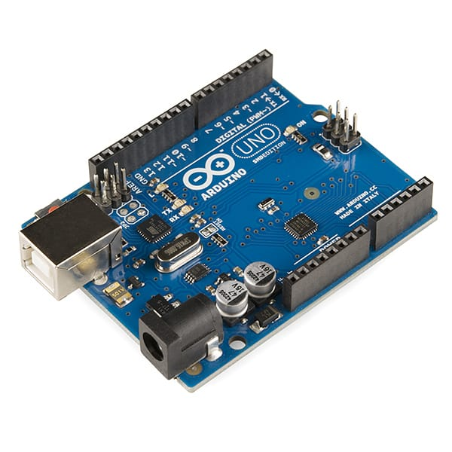

Fig:3.21 Arduino Uno

**Pin description**

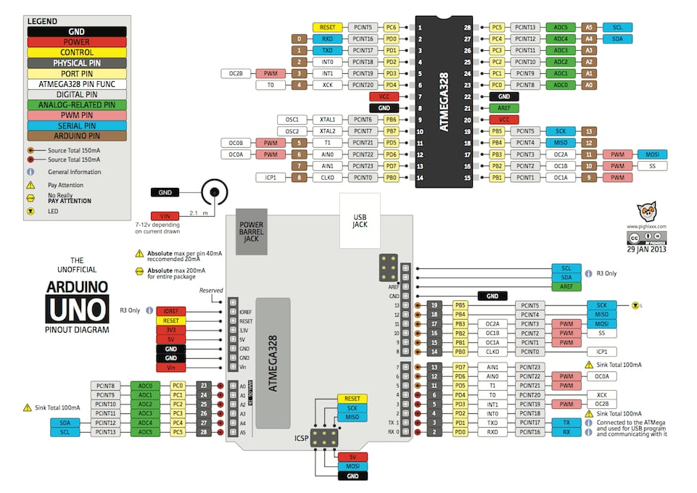

Fig 3.2.1 Pin diagram of Arduino uno

It comprises 14-digit I/O pins. From these pins, 6-pins can be utilized like PWM outputs. This board includes 14 digital input/output pins, Analog inputs-6, a USB connection, quartz crystal16 MHz, a power jack, a USB connection, resonator-16Mhz, a power jack, an ICSP header an RST button.

The power supply of the Arduino can be done with the help of an exterior power supply otherwise USB connection. The exterior power supply (6 to 20 volts) mainly includes a battery or an AC to DC adapter. The connection of an adapter can be done by plugging a center-positive plug (2.1mm) into the power jack on the board. The battery terminals can be placed in the pins of Vin as well as GND. The power pins of an Arduino board include the following.

**Vin:** The input voltage or Vin to the Arduino while it is using an exterior power supply opposite to volts from the connection of USB or else RPS (regulated power supply). By using this pin, one can supply the voltage.

**5Volts:** The RPS can be used to give the power supply to the microcontroller as well as components which are used on the Arduino board. This can approach from the input voltage through a regulator.

**3V3:** A 3.3 supply voltage can be generated with the onboard regulator, and the highest draw current will be 50 mA.

**GND:** GND (ground) pins

**Memory:** The memory of an ATmega328 microcontroller includes 32 KB and 0.5 KB memory is utilized for the Boot loader), and also it includes SRAM-2 KB as well as EEPROM1KB.

**Input and Output:** We know that an arguing Uno R3 includes 14-digital pins which can be used as an input otherwise output by using the functions like pin Mode (), digital Read (), and digital Write (). These pins can operate with 5V, and every digital pin can give or receive 20mA & includes a 20k to 50k ohm pull up resistor. The maximum current on any pin is 40mA which cannot surpass for avoiding the microcontroller from the damage. Additionally, some of the pins of an Arduino include specific functions.

**Serial Pins:** The serial pins of an Arduino board are TX (1) and RX (0) pins and these pins can be used to transfer the TTL serial data. The connection of these pins can be done with the equivalent pins of the ATmega8 U2 USB to TTL chip.

**External Interrupt Pins:** The external interrupt pins of the board are 2 & 3, and these pins can be arranged to activate an interrupt on a rising otherwise falling edge, a low-value otherwise a modify in value.

**PWM Pins:** The PWM pins of an Arduino are 3, 5, 6, 9, 10, & 11, and gives an output of an 8-bit PWM with the function analog Write ().

**SPI (Serial Peripheral Interface) Pins:** The SPI pins are 10, 11, 12, 13 namely SS, MOSI, SPI communication with the help of the SPI library.

**LED Pin:** An arguing board is inbuilt with a LED using digital pin-13. Whenever the digital pin is high, the LED will glow otherwise it will not glow.

**TWI (2-Wire Interface) Pins:** The TWI pins are SDA or A4, & SCL or A5, which can support the communication of TWI with the help of Wire library.

**AREF (Analog Reference) Pin:** An analogue reference pin is the reference voltage to the inputs of an analogue I/p using the function like analog reference.

**Reset (RST) Pin:** This pin brings a low line for resetting the microcontroller, and it is very useful for using an RST button toward shields which can block the one over the Arduino R3 board.

**Communication:** The communication protocols of an Arduino Uno include SPI, I2C, and UART serial communication.

**UART:** An Arduino Uno uses the two functions like the transmitter digital pin1 and the receiver digital pin0. These pins are mainly used in UART TTL serial communication.

**I2C:** An Arduino UNO board employs SDA pin otherwise A4 pin & A5 pin otherwise SCL pin is used for I2C communication with wire library. In this, both the SCL and SDA are CLK signal and data signal.

**SPI Pins:** The SPI communication includes MOSI, MISO, and SCK.

**MOSI (Pin11):** This is the master out slave in the pin, used to transmit the data to the devices

**MISO (Pin12):** This pin is a serial CLK, and the CLK pulse will synchronize the transmission of which is produced by the master.

**SCK (Pin13):** The CLK pulse synchronizes data transmission that is generated by the master. Equivalent pins with the SPI library are employed for the communication of SPI. ICSP (in circuit serial programming) headers can be utilized for programming AT mega microcontroller directly with the boot loader.

**Arduino Uno R3 Programming**

1.The programming of an Arduino Uno R3 can be done using IDE software. The microcontroller on the board will come with pre-burned by a boot loader that permits to upload fresh code without using an exterior hardware programmer.

2.The communication of this can be done using a protocol like STK500.

**Different Types of Arduino Boards:**

The list of Arduino boards includes the following such as

1.Arduino Uno (R3)

2.LilyPad Arduino

3.Red Board

4.Arduino Mega (R3)

5.Arduino Leonardo

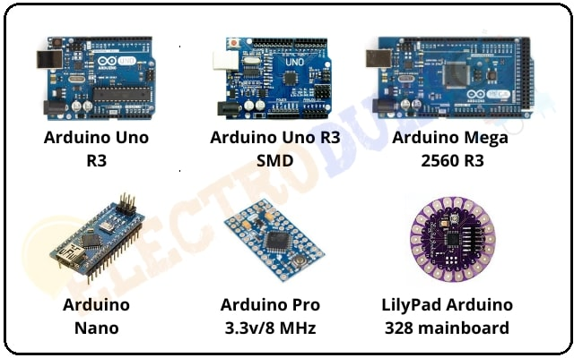

Fig:3.1.3 Types of Arduinos Uno

**Features of Arduino Uno Board**

The features of Arduino Uno ATmega328 includes the following.

• The operating voltage is 5V

• The recommended input voltage will range from 7v to 12V

• The input voltage ranges from 6v to 20V

• Digital input/output pins are 14

• Analog I/p pins are 6

• DC Current for each input/output pin is 40 mA

• DC Current for 3.3V Pin is 50 mA

• Flash Memory is 32 KB

• SRAM is 2 KB

• EEPROM is 1 KB • CLK Speed is 16 MHz

**Advantages:**

• Not much knowledge required to get started.

• Fairly low cost, depending on shields you need.

• Lots of sketches and shields available.

• No external programmer or power supply needed.

**3.2.2 Bread Board**

A breadboard is a solderless device for temporary prototype with electronics and test circuit designs. Most electronic components in electronic circuits can be interconnected by inserting their leads or terminals into the holes and then making connections through wires where appropriate.

The breadboard has strips of metal underneath the board and connect the holes on the top of the board. The metal strips are laid out as shown below. Note that the top and bottom rows of holes are connected vertically.

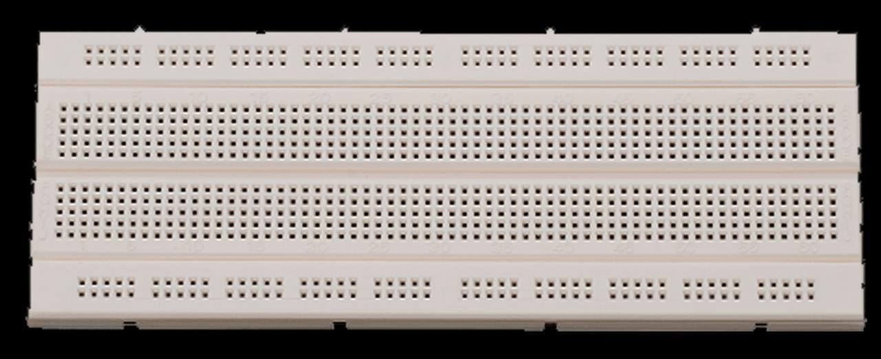

Fig:3.2.1 Layout of Breadboard

Note how all holes in the selected row are connected together, so the holes in the selected column. The set of connected holes can be called a node:

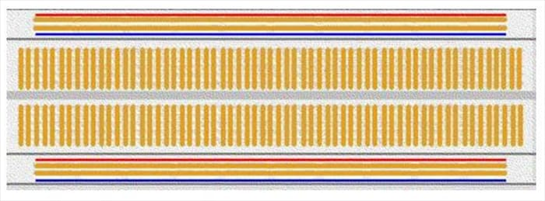

Fig:3.2.2 Internal Structure of Breadboard

**FEATURES**

• 2 Distribution Strips, 200 tie-points

• 630 tie-points in IC circuit areas

• ABS plastic with color legend

• Dimension: 6.5*4.4*0.3 inch

• Hole/Pitch Style: Square wire holes (2.54mm)

• ABS heat Distortion Temperature: 84° C (183° F)

• Rating: 300/3 to 5Amps

• Insulation Resistance: 500MΩ / DC500V

• Withstanding Voltage: 1,000V AC / 1 minute

• Insertion Wire Size: 21 to 26 AWG wire

**3.2.3 Flame sensor:**

A flame-sensor is one kind of detector which is mainly designed for detecting as well as responding to the occurrence of a fire or flame. The flame detection response can depend on its fitting. It includes an alarm system, a natural gas line, propane & a fire suppression system. This sensor is used in industrial boilers. The main function of this is to give authentication whether the boiler is properly Working or not. The response of these sensors is faster as well as more accurate Compare with a heat/smoke detector because of its mechanism while detecting the flame.

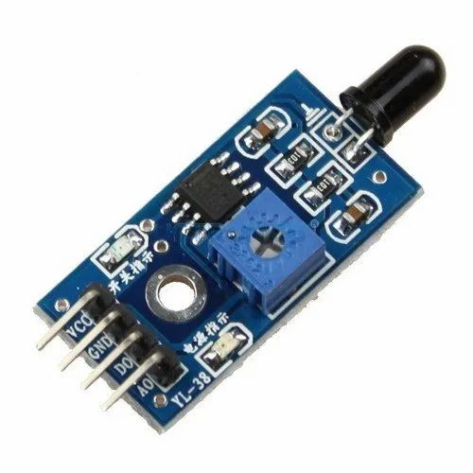

Fig :3.3 Flame sensor

**Working Module:**

This sensor/detector can be built with an electronic circuit using a receiver like electromagnetic radiation. This sensor uses the infrared flame flash method, which allows the sensor to work through a coating of oil, dust, water vapor, otherwise ice.

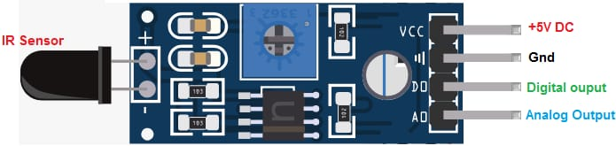

Fig:3.31 Working module of Flame Sensor

Pin1 (VCC pin): Voltage supply rages from 3.3V to 5.3V

Pin2 (GND): This is a ground pin

Pin3 (AOUT): This is an analog output pin (MCU.IO)

Pin4 (DOUT): This is a digital output pin (MCU.IO)

**Different Types**

Flame-sensors are classified into four types:

* IR single frequency
* IR multi-spectrum
* UV flame detectors
* UV/ IR flame detectors

**Features & Specifications**

The features of this sensor include the following.

* Photosensitivity is high
* Response time is fast
* Simple to use
* Sensitivity is adjustable
* Detection angle is 600,
* It is responsive to the flame range.
* Accuracy can be adjustable
* Operating voltage of this sensor is 3.3V to 5V
* Analog voltage o/PS and digital switch o/PS
* The PCB size is 3cm X 1.6cm
* Power indicator & digital switch o/p indicator

**Applications**

These sensors are used in several dangerous situations which include the following

* Hydrogen Industrial heating
* detection
* Fire alarm
* Industrial gas turbines
* Fire Domestic heating systems

**3.2.4 POWER ADAPTER**

An AC/DC adapter, or AC/DC converter [1] is a type of external power supply, often enclosed in a case similar to an AC plug. Other common names include plug pack, plug-in adapter, adapter block, domestic mains adapter, line power adapter, wall wart, power brick, and power adapter. Adapters for battery-powered equipment may be described as chargers or rechargers (see also battery charger). AC adapters are used with electrical devices that require power but do not contain internal components to derive the required voltage and power from mains power. The internal circuitry of an external power supply is very similar to the design that would be used for a built-in or internal supply.

External power supplies are used both with equipment with no other source of power and with battery-powered equipment, where the supply, when plugged in, can sometimes charge the battery in addition to powering the equipment.

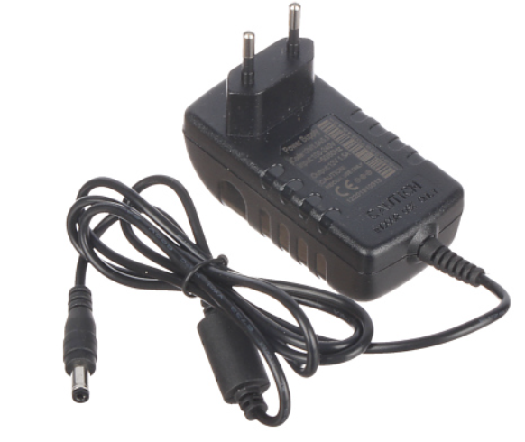

Fig:3.4 AC/DC adapter

**3.2.5 GSM module**

GSM stands for Global System for Mobile Communication. It is a digital cellular technology used for transmitting mobile voice and data services.

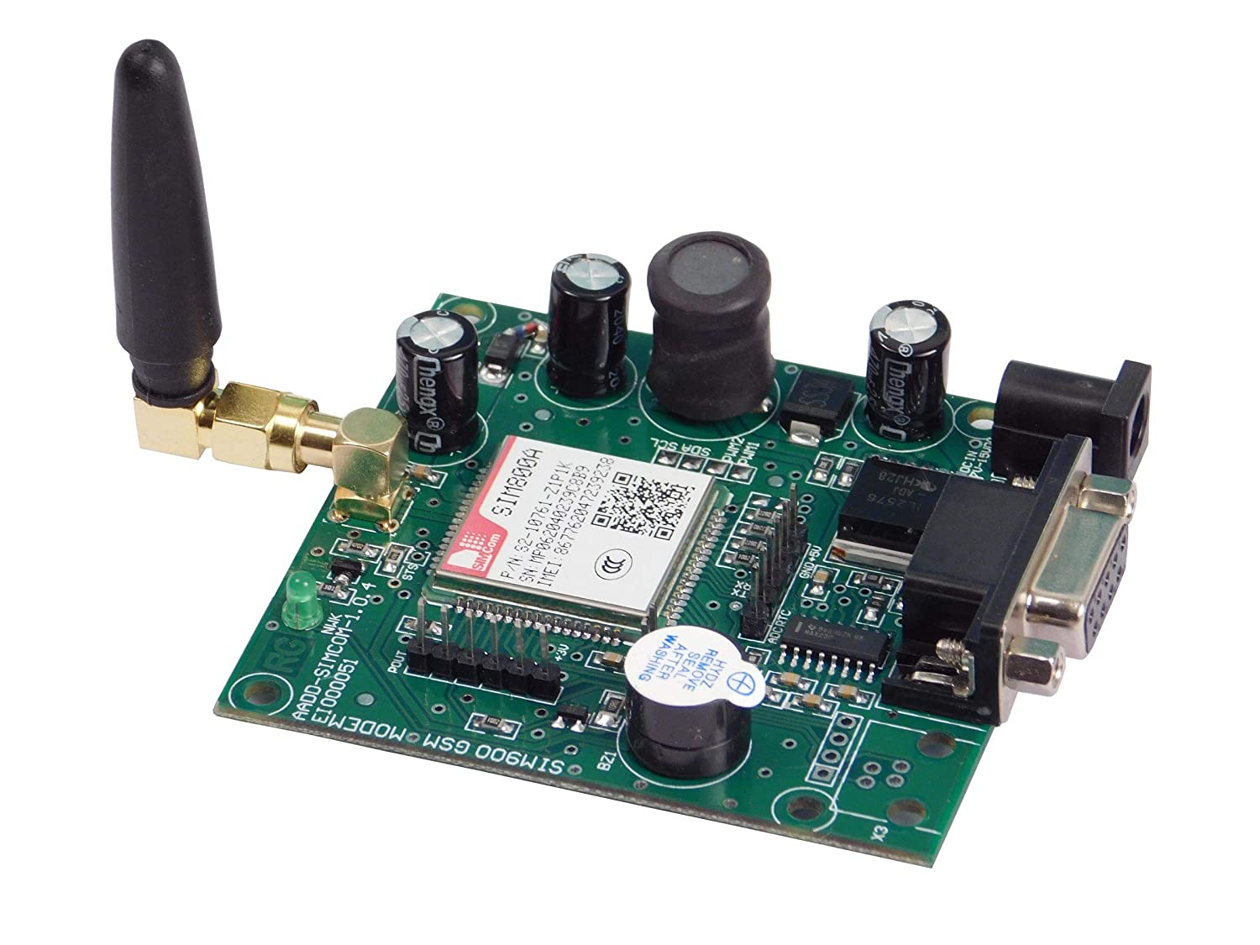

Fig 3.5 GSM module

Important facts about the GSM are given below −

• The concept of GSM emerged from a cell-based mobile radio system at Bell Laboratories in the early 1970s.

• GSM is the name of a standardization group established in 1982 to create a common European mobile telephone standard.

• GSM is the most widely accepted standard in telecommunications and it is implemented globally.

• GSM is a circuit-switched system that divides each 200 kHz channel into eight 25 kHz time-slots. GSM operates on the mobile communication bands 900 MHz and 1800 MHz in most parts of the world. In the US, GSM operates in the bands 850 MHz and 1900MHz.

• GSM owns a market share of more than 70 percent of the world's digital cellular subscribers.

• GSM makes use of narrowband Time Division Multiple Access (TDMA) technique for transmitting signals.

• GSM was developed using digital technology. It has an ability to carry 64 kbps to 120 Mbps of data rates.

• Presently GSM supports more than one billion mobile subscribers in more than 210 countries throughout the world.

• GSM provides basic to advanced voice and data services including roaming service. Roaming is the ability to use your GSM phone number in another GSM network.

**Features of GSM**

Listed below are the features of GSM that account for its popularity and wide

acceptance.

• Improved spectrum efficiency

• International roaming

• Low-cost mobile sets and base stations (BSs)

• High-quality speech

• Compatibility with Integrated Services Digital Network (ISDN) and other

telephone company services

• Support for new services

**GSM Network Division**

• The Mobile Station (MS)

• The Base Station Subsystem (BSS)

• The Network Switching Subsystem (NSS)

• The Operation Support Subsystem (OSS)

The MS consists of the physical equipment, such as the radio transceiver, display and digital signal processors, and the SIM card. It provides the air interface to the user in GSM networks. As such, other services are also provided, which include −

• Voice teleservices

• Data bearer services

• The features' supplementary services

The MS also provides the receptor for SMS messages, enabling the user to toggle between the voice and data use. Moreover, the mobile facilitates access to voice messaging systems. The MS also provides access to the various data services available in a GSM Services

**GSM Services**

• X.25 packet switching through a synchronous or asynchronous dial-up connection to the PAD at speeds typically at 9.6 Kbps.

• General Packet Radio Services (GPRSs) using either an X.25 or IP based data transfer method at the speed up to 115 Kbps.

• High speed, circuit switched data at speeds up to 64 Kbps.We will discuss more about GMS services in GSM - User Services.

**SIM**

The SIM provides personal mobility so that the user can have access to all subscribed services irrespective of both the location of the terminal and the use of a specific terminal. You need to insert the SIM card into another GSM cellular phone to receive calls at that phone, make calls from that phone, or receive other subscribed services.

GSM - The Base Station Subsystem (BSS)

The BSS is composed of two parts −

• The Base Transceiver Station (BTS)

• The Base Station Controller (BSC)

The BTS and the BSC communicate across the specified Abis interface, enabling operations between components that are made by different suppliers. The radio components of a BSS may consist of four to seven or nine cells. A BSS may have one or more base stations. The BSS uses the Abis interface between the BTS and the BSC. A separate high-speed line (T1 or E1) is then connected from the BSS to the Mobile MSC.

**The Base Transceiver Station (BTS)**

The BTS houses the radio transceivers that define a cell and handles the radio link protocols with the MS. In a large urban area, a large number of BTSs may be deployed. The BTS corresponds to the transceivers and antennas used in each cell of the network. A BTS is usually placed in the center of a cell. Its transmitting power defines the size of a cell. Each BTS has between 1 and 16 transceivers, depending on the density of users in the cell. Each BTS serves as a single cell. It also includes the following functions −

• Encoding, encrypting, multiplexing, modulating, and feeding the RF signals to the antenna

• Transcoding and rate adaptation

• Time and frequency synchronizing

• Voice through full- or half-rate services

• Decoding, decrypting, and equalizing received signals

• Random access detection

• Timing advances

• Uplink channel measurements

The Base Station Controller (BSC)

The BSC manages the radio resources for one or more BTSs. It handles radio channel setup, frequency hopping, and handovers. The BSC is the connection between the mobile and the MSC. The BSC also translates the 13 Kbps voice channel used over the radio link to the standard 64 Kbps channel used by the Public Switched Telephone Network (PSDN) or ISDN.

It assigns and releases frequencies and time slots for the MS. The BSC also handles intercell handover. It controls the power transmission of the BSS and MS in its area. The function of the BSC is to allocate the necessary time slots between the BTS and the MSC. It is a switching device that handles the radio resources.

The additional functions include−

• Control of frequency hopping

• Performing traffic concentration to reduce the number of lines from the

MSC

• Providing an interface to the Operations and Maintenance Center for the BSS

• Reallocation of frequencies among BTSs

• Time and frequency synchronization

• Power management

• Time-delay measurements of received signals from the MS

•GSM - The Network Switching Subsystem (NSS)

The Network switching system (NSS), the main part of which is the Mobile Switching Center (MSC), performs the switching of calls between the mobile and other fixed or mobile network users, as well as the management of mobile services such as authentication. The switching system includes the following functional elements −

Home Location Register (HLR)

The HLR is a database used for storage and management of subscriptions. The HLR is considered the most important database, as it stores permanent data about subscribers, including a subscriber's service profile, location information, and activity status. When an individual buys a subscription in the form of SIM, then all the information about this subscription is registered in the HLR of that operator.

Mobile Services Switching Center (MSC)

The central component of the Network Subsystem is the MSC. The MSC performs the switching of calls between the mobile and other fixed or mobile network users, as well as the management of mobile services such as registration, authentication, location updating, handovers, and call routing to a roaming subscriber. It also performs such functions as toll ticketing, network interfacing, common channel signaling, and others. Every MSC is identified by a unique ID.

Visitor Location Register (VLR)

The VLR is a database that contains temporary information about subscribers that is needed by the MSC in order to service visiting subscribers. The VLR is always integrated with the MSC. When a mobile station roams into a new MSC area, the VLR connected to that MSC will request data about the mobile station from the HLR. Later, if the mobile station makes a call, the VLR will have the information needed for call setup without having to interrogate the HLR each time.

Authentication Center (AUC)

The Authentication Center is a protected database that stores a copy of the secret key stored in each subscriber's SIM card, which is used for authentication and ciphering of the radio channel. The AUC protects network operators from different types of fraud found in today's cellular world.

Equipment Identity Register (EIR)

The Equipment Identity Register (EIR) is a database that contains a list of all valid mobile equipment on the network, where its International Mobile Equipment Identity (IMEI) identifies each MS. An IMEI is marked as invalid if it has been reported stolen or is not type approved.

GSM - The Operation Support Subsystem (OSS)

The operations and maintenance center (OMC) is connected to all equipment in the switching system and to the BSC. The implementation of OMC is called the operation and support system (OSS).

Here are some of the OMC functions

• Administration and commercial operation (subscription, end terminals, charging, and statistics).

• Security Management.

• Network configuration, Operation, and Performance Management.

• Maintenance Tasks.

The operation and Maintenance functions are based on the concepts of the Telecommunication Management Network (TMN), which is standardized in the ITU-T series M.30.

Following is the figure, which shows how OMC system covers all the GSM elements.

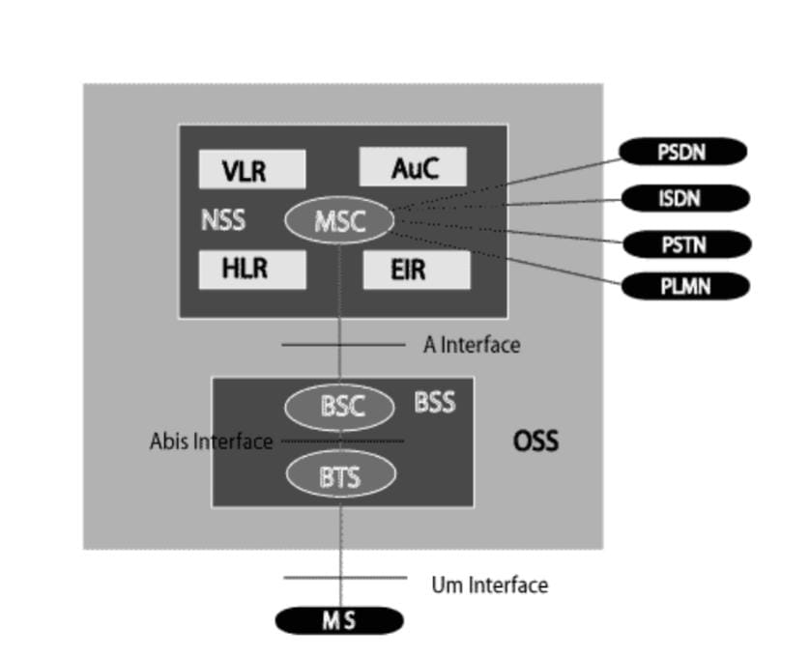

Fig 3.5.4 Base Station Control

The OSS is the functional entity from which the network operator monitors and controls the system. The purpose of OSS is to offer the customer cost-effective support for centralized, regional, and local operational and maintenance activities that are required for a GSM network. An important function of OSS is to provide a network overview and support the maintenance activities of different operation and maintenance organizations

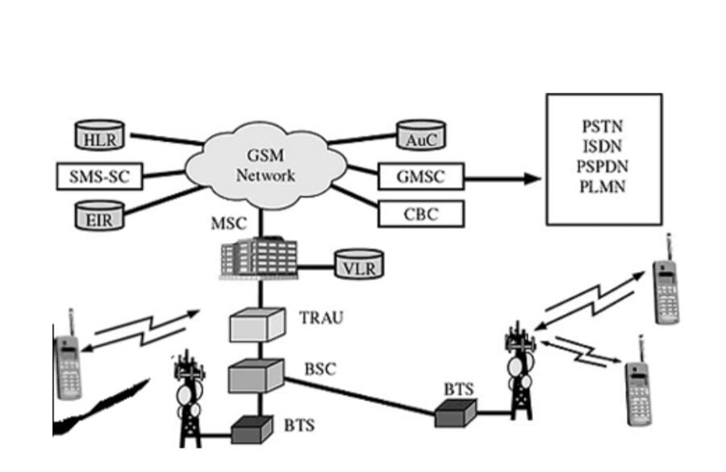

Fig 3.5.5 Pictorial view of the GSM architecture

The additional components of the GSM architecture comprise of databases and messaging systems functions –

• Home Location Register (HLR)

• Visitor Location Register (VLR)

• Equipment Identity Register (EIR)

• Authentication Center (AuC)

• SMS Serving Center (SMS SC)

• Gateway MSC (GMSC)

• Chargeback Center (CBC)

• Transcoder and Adaptation Unit (TRAU)

The following diagram shows the GSM network along with the added elements –

The MS and the BSS communicate across the Um interface. It is also known as the air interface or the radio link. The BSS communicates with the Network Service Switching (NSS) center across the A interface.

GSM network areas

In a GSM network, the following areas are defined −

• Cell − Cell is the basic service area; one BTS covers one cell. Each cell is given a Cell Global Identity (CGI), a number that uniquely identifies the cell.

• Location Area − A group of cells form a Location Area (LA). This is the area that is paged when a subscriber gets an incoming call. Each LA is assigned a Location Area Identity (LAI). Each LA is served by one or more BSCs.

• MSC/VLR Service Area − The area covered by one MSC is called the MSC/VLR service area.

• PLMN − The area covered by one network operator is called the Public Land Mobile Network (PLMN). A PLMN can contain one or more MSCs.

**3.2.6 LED**

LED, in full light-emitting diode, in electronics, a semiconductor device that emits infrared or visible light when charged with an electric current. Visible LEDs are used in many electronic devices as indicator lamps, in automobiles as rear-window and brake lights, and on billboards and signs as alphanumeric displays or even full-color posters. Infrared LEDs are employed in autofocus cameras and television remote controls and also as light sources in fiber-optic telecommunication systems.

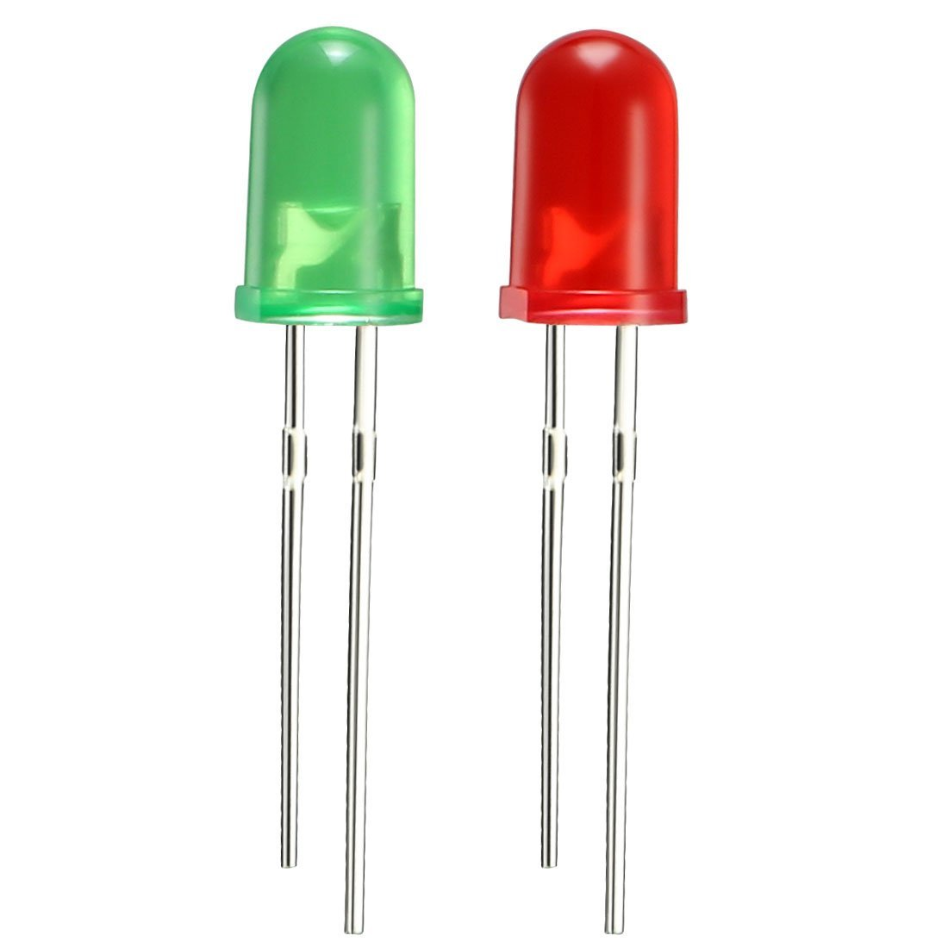

Fig 3.2.6 LED Light

**3.2.7 Water pump**

Pumps operate by some mechanism (typically reciprocating or rotary), and consume energy to perform mechanical work moving the fluid. Pumps operate via many energy sources, including manual operation, electricity, engines, or wind power, and come in many sizes, from microscopic for use in medical applications, to large industrial pumps.

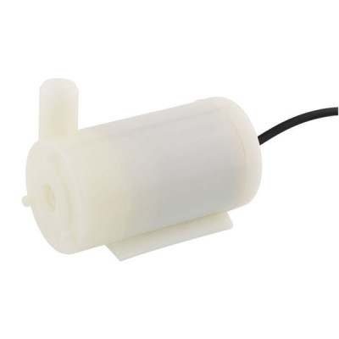

Fig 3.2.7 Water pump

**3.3 Block diagram**

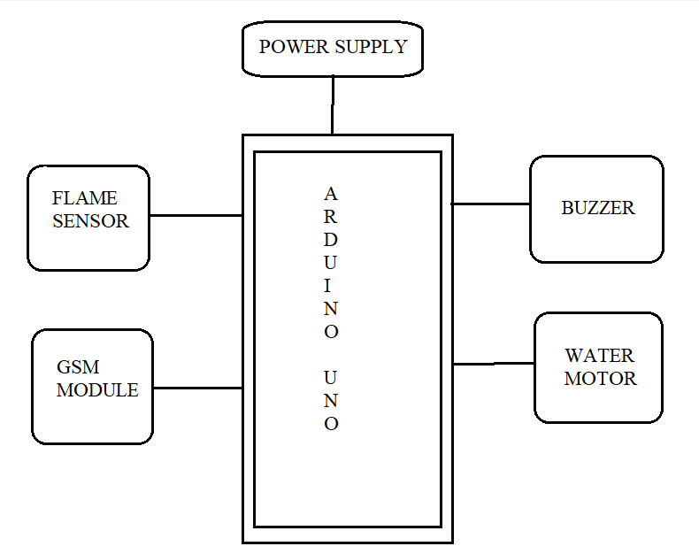

**3.4 Flow chart**

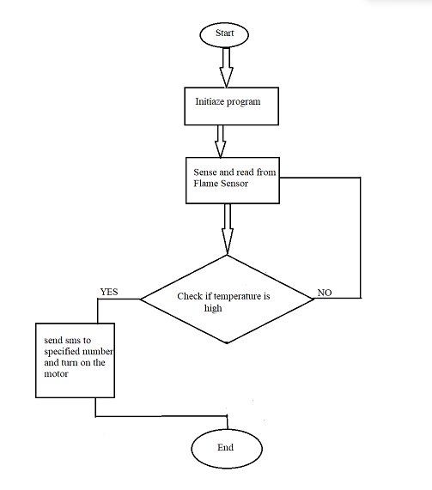

**3.5 Circuit Diagram**

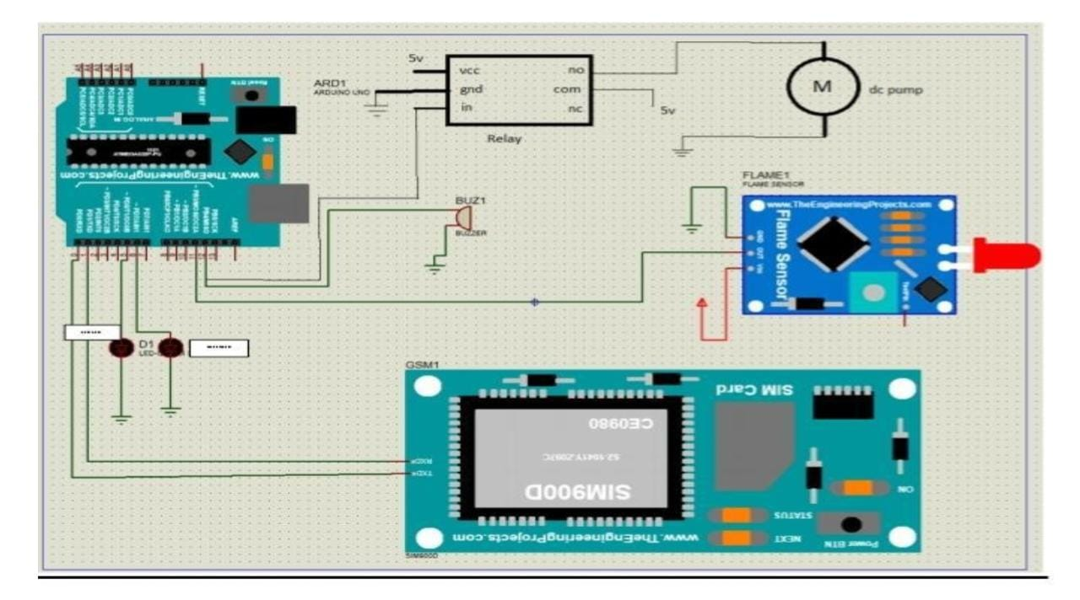

**3.6 Software Development**

The Arduino Integrated Development Environment (IDE) is a cross-platform application (for Windows, macOS, Linux) that is written in functions from C and C++. It is used to write and upload programs to Arduino compatible boards, but also, with the help of third-party cores, other vendor development boards. The source code for the IDE is released under the GNU General Public License, version 2. The Arduino IDE supports the languages C and C++ using special rules of code structuring. The Arduino IDE supplies a software library from the Wiring project, which provides many common input and output procedures. User-written code only requires two basic functions, for starting the sketch and the main program loop, that are compiled and linked with a program stub main () into an executable cyclic executive program with the GNU toolchain, also included with the IDE distribution. The Arduino IDE employs the program converts the executable code into a text file in hexadecimal encoding that is loaded into the Arduino board by a loader program in the board’s firmware. By default, avrdude is used as the uploading tool to flash the user code onto official Arduino boards.

Arduino IDE is a derivative of the Processing IDE, however as of version 2.0, the Processing IDE will be replaced with the Visual Studio Code-based Eclipse Theia IDE framework.

Written in C, C++Operating system

Windows, macOS, Linux Platform IA-32, x86-64,

ARM Type Integrated development environment

License LGPL or GPL license

Website blog.arduino.cc/2020/08/24/cli-and-ide-get-better-together/

With the rising popularity of Arduino as a software platform, other vendors started to implement custom open-source compilers and tools (cores) that can build and upload sketches to other microcontrollers that are not supported by Arduino’s official line of microcontrollers.

In October 2019 the Arduino organization began providing early access to a new Arduino Pro IDE with debugging and other advanced features.

1.Click on Arduino IDE software.



2.Click on the file from the title bar.

3. Click new (or)ctrl +N.

4.The following figure will appear.

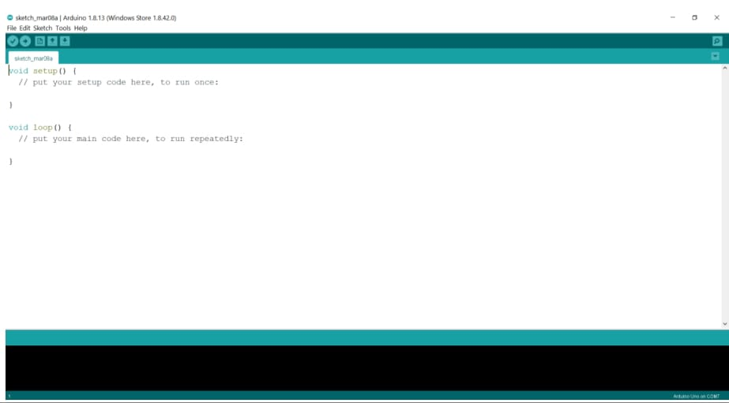

5.Enter the program.

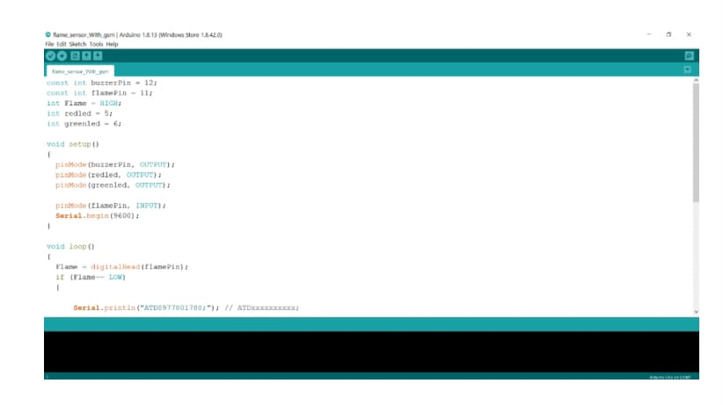

6.Compile the program

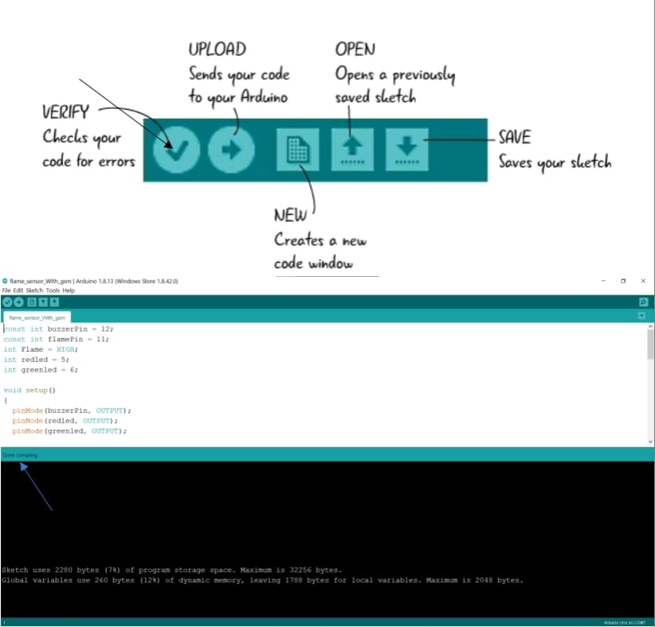

7.Click on the file from the title bar.

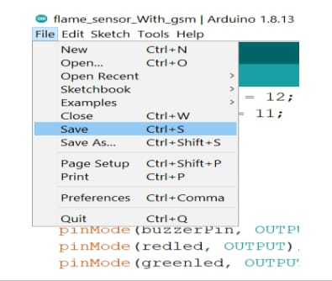

8.Click on save option to save the program

9.Enter the file name for code

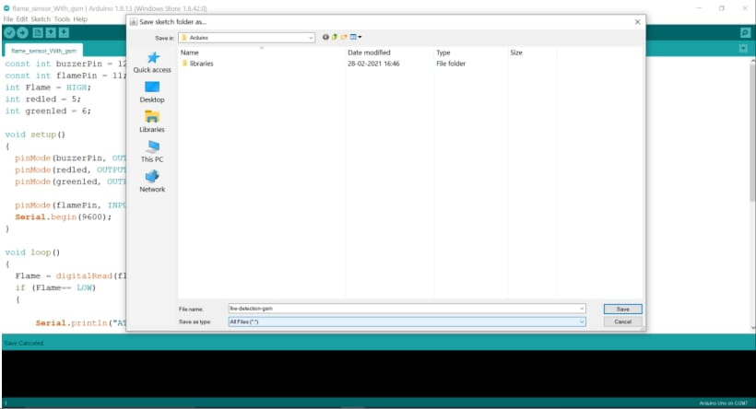

10.Connect your Arduino to computer via USB cable

11.Select Arduino UNO board from the tools section in the tools section in the title🡪 boards

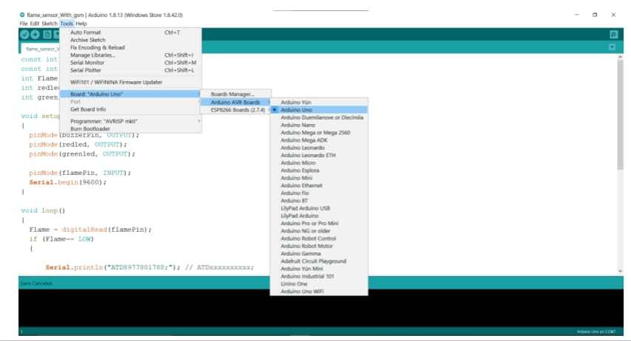

12.Select the respective port from title bar tools🡪port.

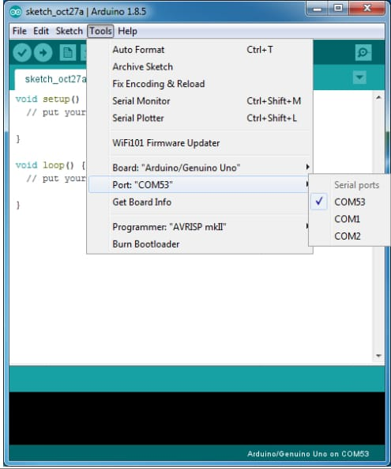

13.Upload the code to Arduino.

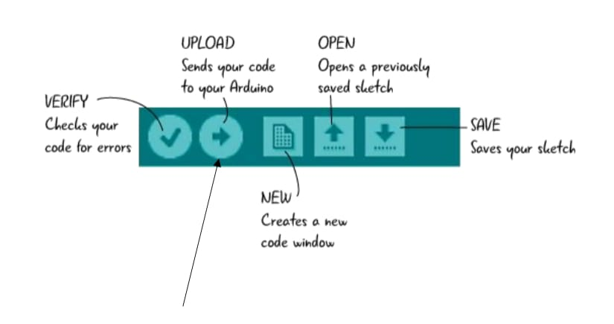

**3.7 Source Code**

#include <SoftwareSerial.h>

SoftwareSerial SIM900(2, 3);

String textForSMS;

int pirsensor = 10;

int buzzer = 9;

int red = 7;

int green = 8;

void setup() {

randomSeed(analogRead(0));

Serial.begin(9600);

SIM900.begin(9600); // original 19200. while enter 9600 for sim900A

Serial.println(" logging time completed!");

pinMode(pirsensor, INPUT);

pinMode(buzzer, OUTPUT);

pinMode(red, OUTPUT);

pinMode(green, OUTPUT);

digitalWrite(buzzer, LOW);

digitalWrite(red, LOW);

digitalWrite(green, LOW);

delay(100);

}

void loop() {

if ( digitalRead(pirsensor) == LOW) //

{

textForSMS = "\ ALERT!! FIRE IN THE INDUSTRY . ";

digitalWrite(buzzer, HIGH);

digitalWrite(red, HIGH);

digitalWrite(green, LOW);

sendSMS(textForSMS);

Serial.println(textForSMS);

Serial.println("message sent.");

delay(1000);

}

if ( digitalRead(pirsensor) == HIGH) //

{

digitalWrite(buzzer, LOW);

digitalWrite(red, LOW);

digitalWrite(green, HIGH);

delay(500);

}}

void sendSMS(String message)

{

SIM900.print("AT+CMGF=1\r"); // AT command to send SMS message

delay(500);

SIM900.println("AT + CMGS = \"+919347088923\""); // recipient's mobile number, in international

format

delay(500);

SIM900.println(message); // message to send

SIM900.println((char)26); // End AT command with a ^Z, ASCII code 26

delay(500);

SIM900.println();

// give module time to send SMS

}

**3.8 Working**

We had connected the GSM module to the Arduino and the flame sensor given as input to the Arduino. We have also connected buzzer for local alert and also connected a water motor for fire control.When the fire is detected police/owner will get the call and the message alert and a buzzer sound is also produced.

**Conclusion:**

The purpose of this project is to assist building owners in overcoming the issue of fire spreading when the owner is not present in the structure. Resident spaces and the building are constantly prone to unexpected or critical situations that go unnoticed by those within. Residents can use the home alert system to keep their homes safe, according to the findings. Compared to other alarm systems already on the market, the one we designed is really affordable, and it's simple to install in most residences. The usage of LM35 in the system ensures that the system is able to detect heat or high temperatures. Because of its adaptability and ease of use, this gadget may be used in a wide range of settings, including homes, hostels, hotels, factories, and the transportation industry, among many others. Users only need to place the device where they want it to work to keep their desired area safe from the threat of oncoming flames. When the gadget detects that the temperature has risen over the preset threshold (40 degrees Celsius), a GSM text message will be sent to the consumers immediately. This will make the users aware of the dangerous condition, and they will be able to quickly prevent it (use a fire extinguisher, phone the fire department, etc.) from occurring.

**FUTURE-SCOPE:**

The project can be extended in adding sensors like gas sensor, Temperature sensor. We can make use of ESP8266 Nodemcu and monitor the changes through The internet. And control the damage to the industry. This project can also be incorporated in automatic robotic system for Industrial security application. Through GPS easy identification of location can be obtained further adding of GPS tracking

**References:**

1. [An Automated Fire Suppression Mechanism Controlled using an Arduino | IEEE Conference Publication | IEEE Xplore](https://ieeexplore.ieee.org/document/8674078/)

2. [Arduino based Sensor Equipped Fire Surveillance Drone | IEEE Conference Publication | IEEE Xplore](https://ieeexplore.ieee.org/document/9121043)

3. [Internet of Things (IoT) Based Fire Alert Monitoring System for Car Parking | IEEE Conference Publication | IEEE Xplore](https://ieeexplore.ieee.org/document/9102613)

4. [Smart Fire Detection and Security System | IEEE Conference Publication | IEEE Xplore](https://ieeexplore.ieee.org/document/9666623)

5. [A Fire-Detection and Control System in Automobiles: Implementing a Design That Uses Fuzzy Logic to Anticipate and Respond | IEEE Journals & Magazine | IEEE Xplore](https://ieeexplore.ieee.org/document/8602441)

6. [An IoT based fire alarming and authentication system for workhouse using Raspberry Pi 3 | IEEE Conference Publication | IEEE Xplore](https://ieeexplore.ieee.org/document/7913031)

7. [IoT based Smart Sensing and Alarming System with Autonomous Guiding Robots for Efficient Fire Emergency Evacuation | IEEE Conference Publication | IEEE Xplore](https://ieeexplore.ieee.org/document/9456142)

8. [Design of intelligent fire alarm system based on GSM network | IEEE Conference Publication | IEEE Xplore](https://ieeexplore.ieee.org/document/6013128)

9. [Home Intelligent Fire Alarm System Based on STM32 | IEEE Conference Publication | IEEE Xplore](https://ieeexplore.ieee.org/document/9723911)

10. [Design and implementation of the mobile fire alarm system using wireless sensor networks | IEEE Conference Publication | IEEE Xplore](https://ieeexplore.ieee.org/document/7846411)

11. [Design of the Intelligent Test Equipment of Airplane Fire Alarm System | IEEE Conference Publication | IEEE Xplore](https://ieeexplore.ieee.org/document/5634755)